Here are a few examples of what our
facilitators say about their work at
Children’s Grief Center:

“This is the most rewarding thing I do.”

“I always get more than I give.”

“It is truly an honor to work with these
families.”

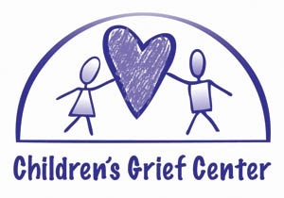
Our groups are open & ongoing. Facilitators trained at this time will be added to existing groups as space is available.

Facilitating groups requires a commitment of attending each group – from 5:15pm – 8:30pm every other week. Groups in the North Valley meet Tuesday, Wednesday, and Thursday. Rio Rancho Groups meet on alternating Thursdays. There is a winter break in December. Through the course of a 12 month commitment, volunteers attend about 18 groups.
CGC also holds special events in summer and trained facilitators are needed to support bereaved youth.

We thank you for your interest in our training program and for helping bereaved families.

Volunteer Guidelines

All volunteer bereavement facilitators are required to:

- Supply information needed for us to run a background check.
- Wait for at least one year since the loss of a significant person in the volunteer’s life.
- Attend the entire 2-day training.
- Complete a volunteer application.
- Sign a volunteer agreement.

At the end of the training, a trainee’s readiness to become a facilitator will be reviewed.

Questions?

Please call 505-323-0478

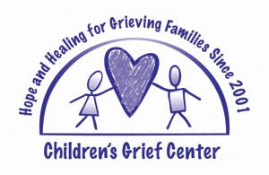

Offering hope & healing to grieving families since 2001.

Bereavement
Facilitator Training

3001 Trellis NW
Albuquerque, NM 87107
www.childrensgrief.org
info@childrensgrief.org
505-323-0478

Facilitators
Training
Volunteer Bereavement Facilitators
Training

The mission of Children’s Grief Center of New Mexico is to provide a safe and supportive environment in which children, teens and their families can share experiences and feelings while grieving a death.

Children’s Grief Center is a special 501(c) 3 nonprofit organization that provides bereavement support groups for children ages 5—18, young adults ages 18-25, and their caregivers.
The support groups are led by specially trained volunteer facilitators. All services are free to families.

Bereavement Facilitator
2-Day Training Schedule:
Two Full Days
8:30am – 5:00pm
(lunch provided)

The training fee you pay helps defray some of the costs of meals, handouts, materials, and your criminal background check. Thank you!

This training is designed for individuals
interested in volunteering to serve as
facilitators for the Center’s support groups. Individuals who do not plan to volunteer will find the information helpful in their own professional setting, and will be accepted on a space-available basis.

Training Objectives:

- To understand the normal, human grief response to death/loss
- To recognize the need for grief support for children, teens and adults
- To develop skills as a support group facilitator
- To explore personal beliefs about death and dying
- To experience facilitating a support group

13 CEUs for counselors, psychologists, and
social workers are available.
Please remember that you do not need to be a counselor, therapist or mental health professional to become a volunteer facilitator.

Training Fee: $260.00 for 13 CEUs, or $150.00
for 7.5 CEUs.
Substantial discounts
with your volunteer commitment

REGISTRATION FORM
Name: _____________________________________________ E-mail:___________________________________

Address: ________________________________________________ City:_______________ Zip:______________

Phone: (DAY)____________________________ (EVENING)____________________________

❑ Enclosed is $45.00 to cover the registration fee. I will sign a 12-month volunteer agreement.

❑ Enclosed is $260.00 for 13 CEUs, (the entire 2 day training).

❑ Enclosed is $150.00 for 7.5 CEUs, the core academic information (1 day of training).
❑ I am not interested in the training, but please accept my donation to the Children’s Grief Center of New Mexico.
Please return to: Children’s Grief Center of New Mexico, 3001 Trellis NW, Albuquerque, NM 87107

(For Office Use)
Payment ______
App ______
Bckrgnd ______

